HW 4.3: Tie it together
- Test the hypothesis that less than 17% of college students are smokers at the α = 0.05 level.
Hypotheses
For the claim above, we set the hypotheses as follows.
H0: Psmokers=>17%
H1: Psmokers <17%

Assumptions
- The data is made up of basic random values drawn from the population.
- A binomial distribution is used to describe the population.

To test the above assumptions, we conduct the Shapiro-Wilk test for normality and below is the output.
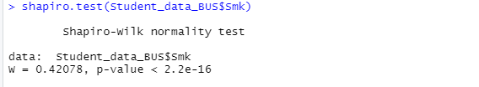
Figure 1: Shapiro- Wilk test for the variable Smk.
Since the p-value<0.05, implies that the data distribution are significantly different from the normal distribution. Hence we cannot assume normality.
We therefore conduct a hypothesis test to test if the proportion of students who smoke is less than 17% and we obtained the following output.
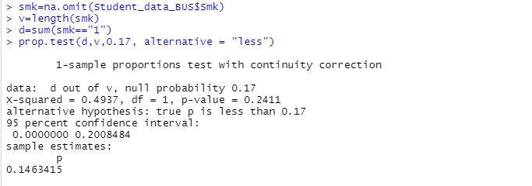
Figure 2: R output for the hypothesis test on true proportion.

From the output above, p-value>0.05, hence we fail to reject the null hypothesis and conclude that there is insufficient evidence to warrant upholding the claim that proportion of students who actually smoke is less than 17%.
- Provide and interpret a two-sided 94% confidence interval for the true average hours worked per week.
For true average hours worked, the output below indicates the 94% confidence interval as from the R output.
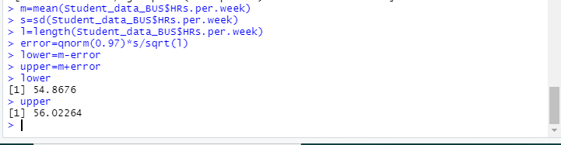
Figure 3: R output for the confidence interval.

From the output above, we can conclude that one can be 94% confident that the average hours worked in a week will fall between (54.8676, 56.02264) which is our confidence interval.

- Test the hypothesis that the students’ reaction time is greater than 170 milliseconds at the α = 0.10 level.
Hypotheses
H0: µ=<170 milliseconds
H1: µ> 170 milliseconds

Assumptions
- We make the assumption that the data is obtained from a population with normal distribution.
To test this we conduct the Shapiro- Wilk test for the test for normality and below is the output.

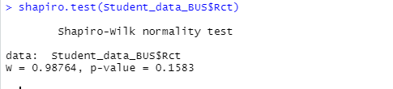
Figure 4: R output for the Shapiro-Wilk Test for normality.

From the output above we find out that p-value>0.1583. Hence we can conclude that, we assume normality since there is no significance difference to a normally distributed population.
Below is the R output for the test that the mean is greater than 170.
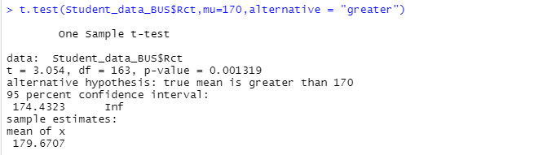
Figure 5: R output for the hypothesis test for average reaction for students.
From the output above, p-value<0.05, hence we reject the null hypothesis and hence conclude that there is sufficient evidence to fail to reject the claim that the students reaction time is greater than 170 milliseconds at α=0.10.

- Provide and interpret a two-sided 99% confidence interval for the true proportion of accounting majors.
Two sided 99% confidence interval is calculated with the output below.
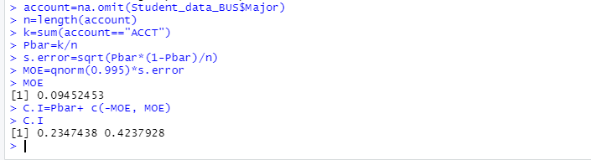
Figure 6: R output for the 99% confidence interval for proportion of accounting majors.

From the output above, at 99% confidence level between 23.4744% and 42.3793% of the people involved in the survey, they majored in accounting having a margin of error pf 9.4524%.
The confidence interval therefore is (0.234744, 0.423793).

